Q1: Create basic calculator application on Console Application that perform basic arithmetic operations like(add,subtract,multiply,divide ….)

Code:-

Calculator Class:-

class Calculator

{

double a;

double b;

public Calculator() { }

public Calculator(double num1,double num2)

{

this.a = num1;

this.b = num2;

}

public double add()

{

return a + b;

}

public double subtract()

{

return a - b;

}

public double multiply()

{

return a * b;

}

public double divide()

{

return a / b;

}

}

Main:-

static void Main(string[] args)

{

Console.WriteLine("|--------------Calculator--------------|");

Console.WriteLine("Enter Two NUmbers for Performing Calculation");

Console.Write("Enter Number 1 : ");

double num1 = double.Parse(Console.ReadLine());

Console.Write("Enter Number 2 : ");

double num2 = double.Parse(Console.ReadLine());

Calculator obj = new Calculator(num1, num2);

while (true)

{

Console.WriteLine("Now what action you want to perform");

Console.WriteLine("1-Add\n2-Subtract\n3-Multiply\n4-Divide\n0-Exit");

int opt = int.Parse(Console.ReadLine());

if (opt == 1)

{

Console.WriteLine("Addition of {0} + {1} = {2}",num1,num2,obj.add());

}

else if (opt == 2)

{

Console.WriteLine("Subtraction of {0} - {1} = {2}", num1, num2, obj.subtract());

}

else if (opt == 3)

{

Console.WriteLine("Multiplication of {0} * {1} = {2}", num1, num2, obj.multiply());

}

else if (opt == 4)

{

Console.WriteLine("Division of {0} / {1} = {2}", num1, num2, obj.divide());

}

else if (opt==0)

{

Console.WriteLine("Successfully Exit..Good Byee..");

Environment.Exit(0);

}

}

}

Output:-

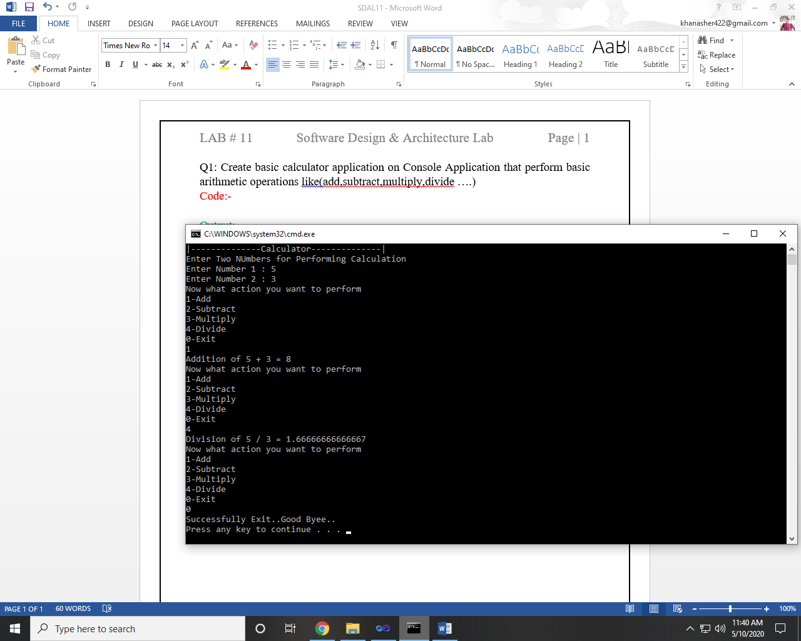

Q2: Create Winform application that authenticate user with hardcoded username and password if user authenticated new form will be open that takes user information as an input and on button click all information will be displayed in dialog box.

Code:-

Form1:

private void button1_Click(object sender, EventArgs e)

{

string username = "Aqib";

string password = "aqib123";

if (user_name.Text==username && pass.Text==password)

{

Form2 form2 = new Form2();

this.Hide();

form2.Show();

}

}

Form2:

private void btn_submit_Click(object sender, EventArgs e)

{

string fisrtname = fname.Text;

string lastname = lname.Text;

string cl = clas.Text;

string sec = sect.Text;

string ph = phon.Text;

string email = mail.Text;

MessageBox.Show("Name : "+fisrtname+" "+lastname+"\nClass : "+cl+"\nSection : "+sec+"\nPhone : "+ph+"\nEmail : "+email);

}

Output:-

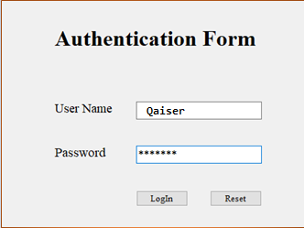

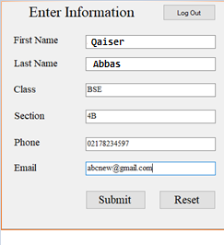

~~~~~~**/**THE END**/**~~~~~~